**Git Commands: Step By Step Guide (Part 2)**

we will go through Git commands related to **Branching** and **Merging**. Branches are used to develop features isolated from each other. It represents an independent line of development. The master branch is the “**default**” branch when you create a repository. Use other branches for development and merge them back to the master branch upon completion.

**1. Checkout a repository:**

To create a working copy of a local repository by running the command

git clone /path/to/repository

when using a remote server, your command will be

git clone username@host:/path/to/repository

In our case, as it is public Github repo so simple link is used

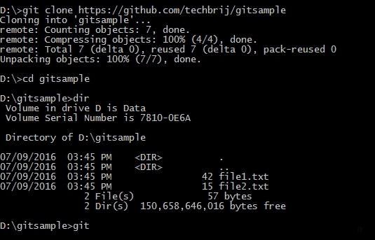

**2. Branching:**

Let’s create a new branch “**branch1**” and switch on it

git checkout -b branch1

Modify **file2.txt** manually then check **status** and **commit** it.

git status

git commit -am "Branch1 first commit"

To **push** the branch to your remote repository, so others can use it:

git push -u origin branch1

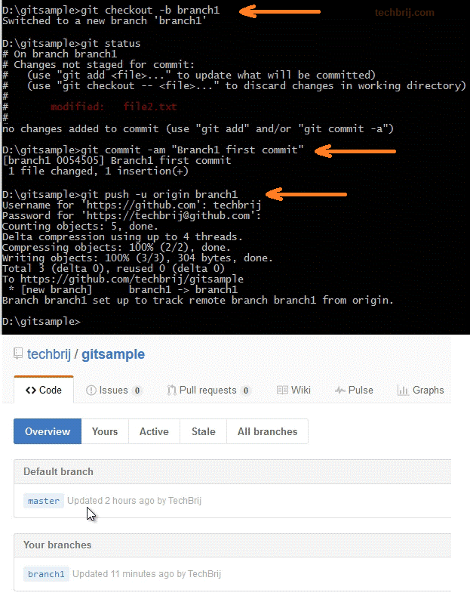

To list all the branches in your repository and to know what branch you’re currently in, run following command:

git branch

To switch from one branch to another:

git checkout <branchname>

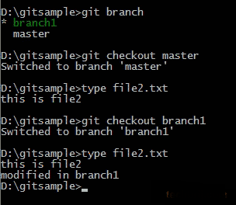

**3. Merging:**

Before merging, you can preview the changes using git diff command:

git diff master branch1

If everything looks okay then use following command to to merge **branch1**into your active branch (e.g. **master**)

git merge branch1

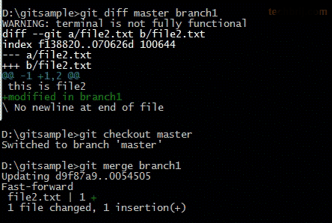

**4. Update your code:**

To update your local repository to the newest commit from the remote repository, run following command:

git pull

**5. Undo Local Changes:**

If you want to sync local code with remote code and drop all your local changes and commits then run following command:

git fetch origin

git reset --hard origin/master

**6. Reset Last commit only:**

If you do wrong commit by mistake and want to remove all changes in last commit, run following command

git reset --hard HEAD~1

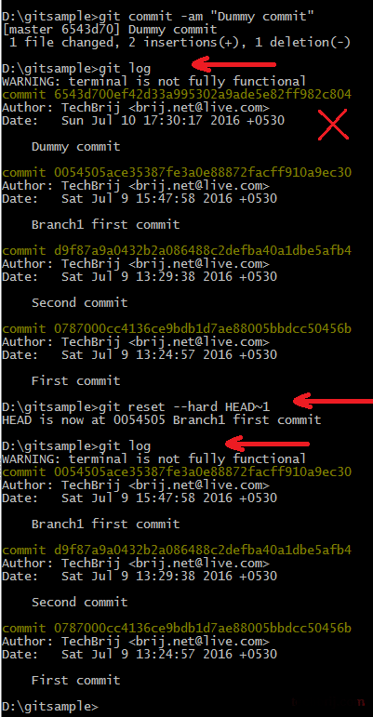

**Conclusion:**

In this tutorial, we have covered basic Git commands related to branching and merging.  
Here is [**Oliver Steele’s image**](http://stackoverflow.com/a/30733500/194345) of how all it all fits together:

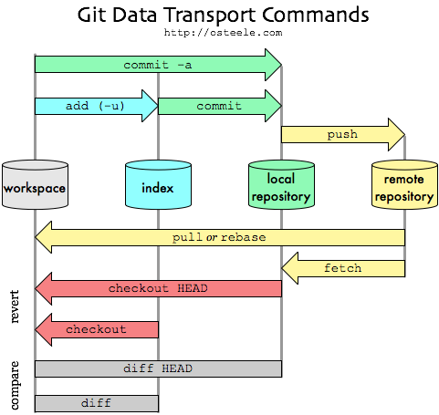

Hope, It helps. Enjoy Git !!